**SCHOOL UNIFORM PRICE LIST**

|  |  |  |  |
| --- | --- | --- | --- |
| **Paterson Polo Shirt**  Size 4 – 2XL | $35.00 | **Football Shorts**  Size 14, 16, S, M | $30.00 |
| **Paterson Hoodie**  Size 4 - 2XL | $48.00 | **Microfibre Shorts**  Size 6 – 3XL | $18.00 |
| **Fleecy Straight Leg Track Pant**  Size 4 - 16  Size S - 2XL | $20.00  $25.00 | **Unisex Shorts**  Size 6 - Large | $22.00 |
| **Fleecy Double Knee Cuff Leg Track Pant**  Size 4 - 16 | $22.00 | **Girls Dress**  Size 4 - 18 | $50.00 |
| **Bucket Hats**  Size XS – S  Size S – M  Size M – L  Size L – XL | $10.00 | **Uniforms can be purchased from the Administration** | |

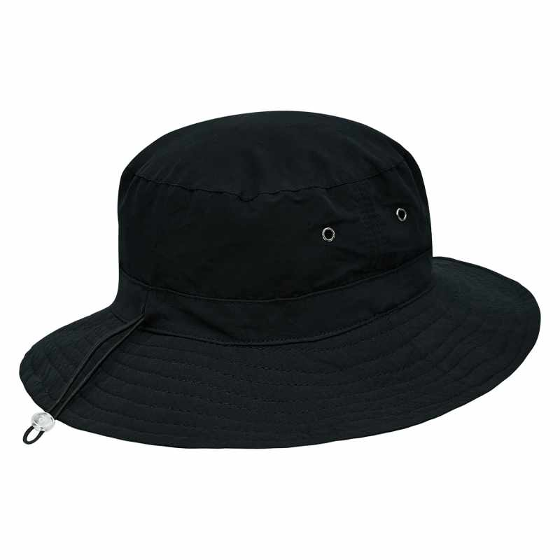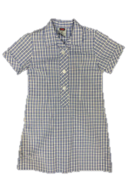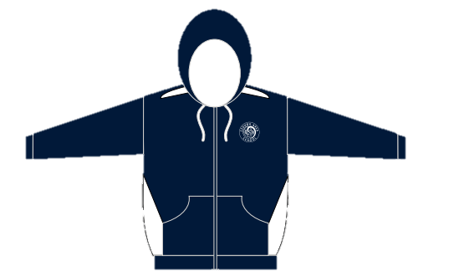

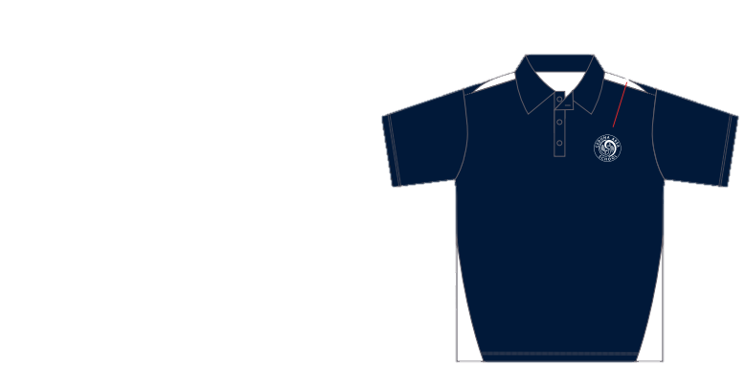**Updated 4/4/2023**