Dress Code Policy

|  |  |
| --- | --- |
| Publication Date | September 2022 |
| Review Date | Reviewed May 2025  Next review February 2028 |
| Related Department for Education policies, procedures, guidelines, standards, frameworks | DfE School Dress Code Administrative Instruction |
| Responsibility | School Leadership and Governing Council |

**Context**

Ceduna Area School believes that a school uniform plays an important role in promoting a positive image of the School and creating a sense of identity and belonging for our students while they are at School and in the Community. All Students, Parents and Staff have a role to play in working collaboratively to encourage compliance with the school uniform and dress code standards.

We believe we have options that are comfortable, inclusive, functional for our climatic conditions and affordable.

In making decisions about the dress code our Governing Council considers cost and other factors that may impact on our families.

**Uniform Compliance**

Positive reinforcement and encouraging responsible behaviour, School connection and belonging are the preferred approaches to ensuring Students comply with the School’s dress code, however the Principal (or delegate) must enforce the dress code and may take appropriate disciplinary action when Students intentionally and persistently ignore reasonable requests to comply with the dress code.

Disciplinary action will not include suspension, exclusion, or expulsion of a Student, or prevent a Student from participating in their education.

If Students present at School in non-uniform items, in the first instance they will be spoken to and a warning given. In the second or continuing instances Parents will be contacted asking for their support in the wearing of the designated School uniform. A behavioural instance will be recorded in Daymap detailing the non compliance.

Students are able to wear their SAPSASA jumper only in the year of participation. For excursions and School Photos the Students must use the School Dress Code Policy.

If Students are not in full uniform they will be unable to attend excursions as representatives of our School or participate in School Photos.

If Students are persistently failing to comply with our dress code we will work collaboratively with Parents/Caregivers to overcome potential barriers to compliance.

**Acceptable Uniform Items**

Students are permitted to use any of the selection of Uniform options listed below. Bags are an optional item. Students can also wear plain Navy shirts, jumpers, shorts or pants if they wish.

The Year 12 cohort are able to design and produce a Commemorative Windcheater in their final year of Schooling. The windcheater should be predominantly in the School colours and be available to all Year 12’s to purchase.

The School strongly encourages Students to take appropriate precautions against skin cancer and apply sunscreen and wear hats at all times when outside. Students without hats are required to move to solid shade areas when in the yard at break times.

**Shoes/Socks**

Students are required to wear closed shoes when in any of the School workshops, kitchens or laboratories. Appropriate footwear is also required for PE lessons. Platform shoes, thongs, ugg boots or other “flip flop” type shoes are not acceptable. Navy, black or white socks are acceptable.

**Jewellery/Make Up**

Jewellery items and any make up should be discrete and be appropriate for a work/school environment. Dangly and bulky jewellery items are not permitted.

**Ceduna Area School Uniform**

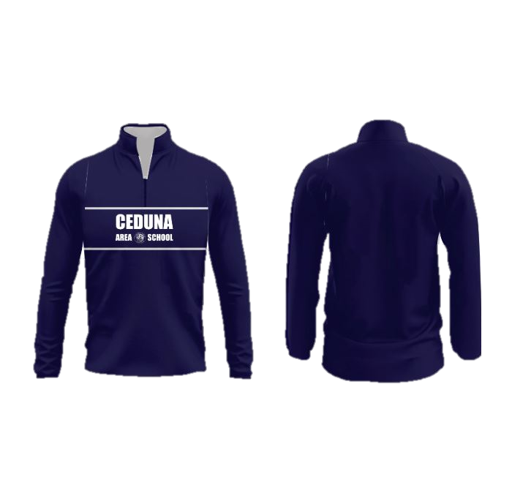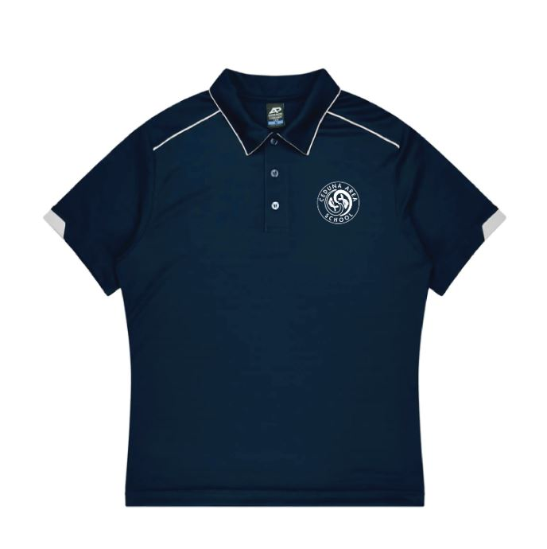

Polo Shirt - $35

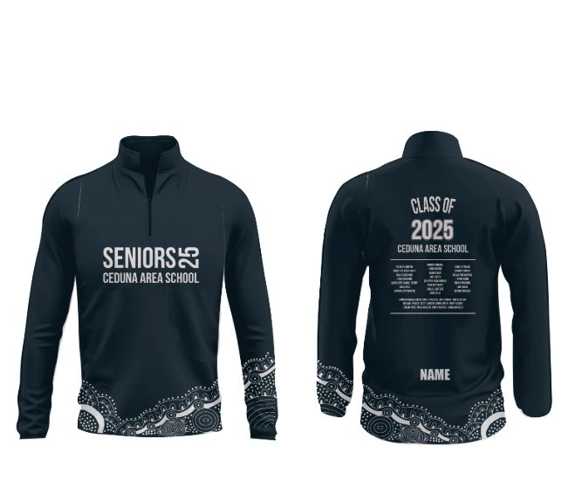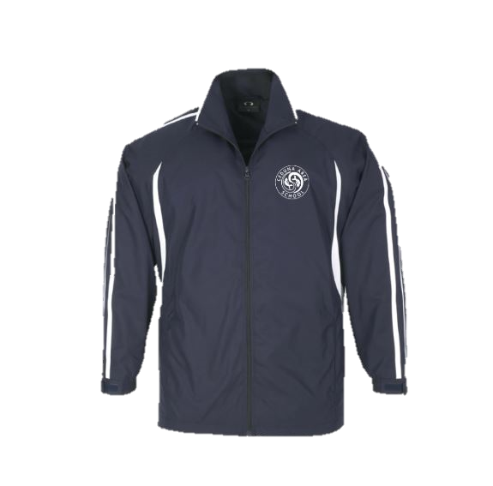

School Leavers ½ zip - $75

Boss Top Jumper - $65

Jacket - $60

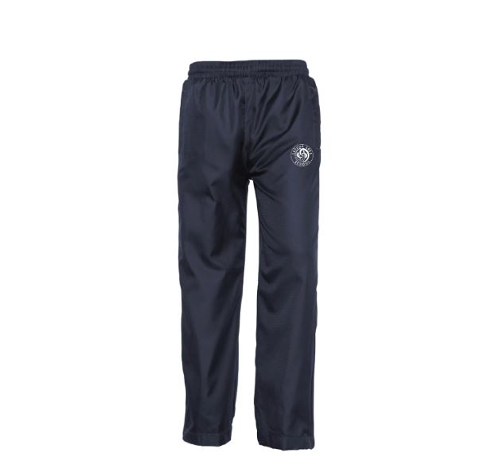

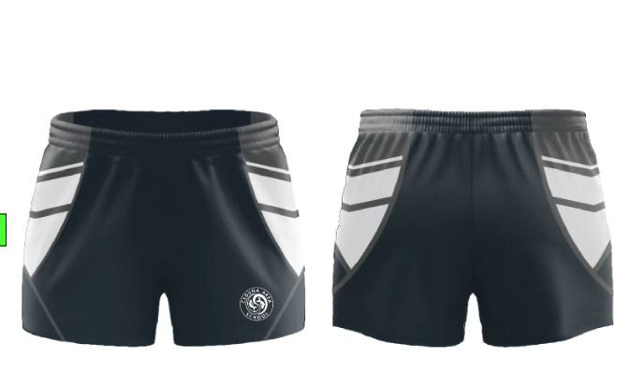

Football Shorts - $40

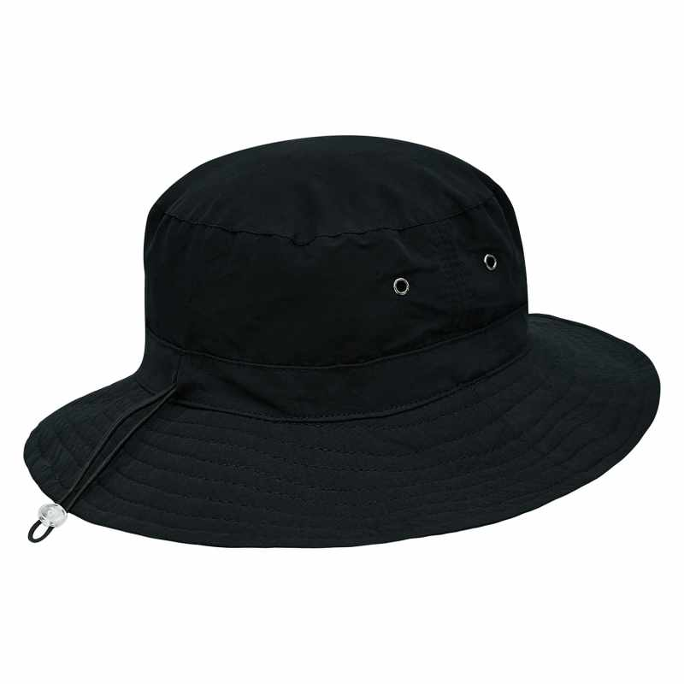

Track Pant - $45

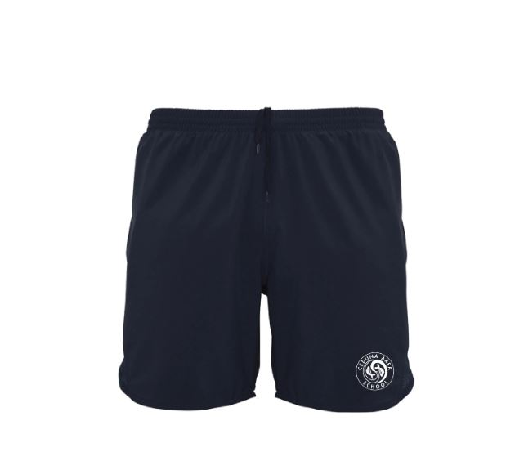

Microfibre Bucket Hat - $10

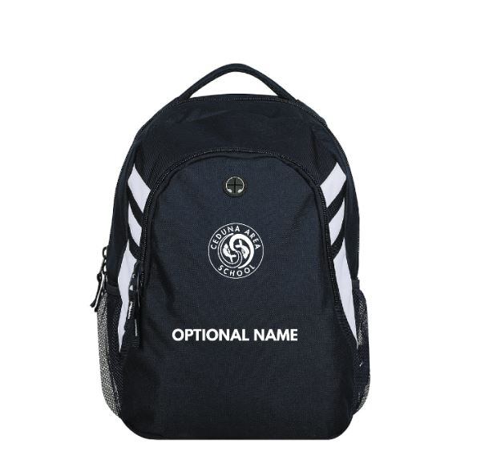

Shorts - $30

Back Pack - $30

**Uniform Purchase**

School uniform items can be purchased online from the Ace Clothing Website – <https://theacegroup.au/collections/ceduna-area-school>

Families experiencing financial hardship can make arrangements through the school in regards to ordering and paying them off.

**Exemption**

Parents may seek exemption from the School Dress Code for a variety of reasons, including but not limited to religious, cultural, gender expression, disability or ethnic reasons.

Parents must provide a written request to the Principal outlining the reasons for the exemption.

**Review Provision**

The Principal may commence a review of the Student Dress Code at any time. Students and Parents of Students enrolled at Ceduna Area School may write to the Principal seeking a review when circumstances change significantly or issues arise.